A MINOR PROJECT REPORT

ON

“BID OUT”

Submitted in partial fulfilment of the requirement for the award of the degree of

MASTER OF COMPUTER APPLICATION
by

YOGESH KUMAR PANDEY
(Roll No: 2024073074)

Under the Guidance of

Ms. Pranjal Maurya
Assistant Professor, ITCA Dept.



DEPARTMENT OF INFORMATION TECHNOLOGY AND COMPUTER APPLICATION
MADAN MOHAN MALAVIYA UNIVERSITY OF TECHNOLOGY GORAKHPUR – 273010
SESSION – 2024-26

Declaration
I, Yogesh Kumar Pandey, have completed the project titled “Bid Out” under the guidance of Ms. Pranjal Maurya in the partial fulfilment of the requirement for the award of Degree of Master of Computer Applications of Madan Mohan Malaviya University of Technology, Gorakhpur. This is an original piece of work, and I have neither copied nor submitted it earlier elsewhere.

Yogesh Kumar Pandey
Roll No: 2024073074
Master of Computer Applications
Madan Mohan Malaviya University of Technology Gorakhpur

Certificate
This is to certify that the project titled “Bid Out” is an academic work done by “Yogesh Kumar Pandey” submitted in the partial fulfilment of the requirement for the award of the Degree of “Master of Computer Applications” from “Madan Mohan Malaviya University of Technology, Gorakhpur” under my guidance & direction. To the best of my knowledge and belief the data & information presented by him in the project has not been submitted earlier.

Ms. Pranjal Maurya

(Project Supervisor)

Acknowledgement

I am extremely grateful and remain indebted to my guide Ms. Pranjal Maurya for being a source of inspiration and for their constant support in the Design, Implementation and Evaluation of the project. I am thankful for constant constructive criticism and invaluable suggestions, which benefited me a lot while developing the project on “Bid Out”. With candor and pleasure, I take the opportunity to express my sincere thanks and obligation to the faculty members. Through this column, it would be my utmost pleasure to express my warm thanks to them for the encouragement, co-operation and consent without which I might not be able to accomplish this project.

Yogesh Kumar Pandey

(M.C.A. 3rd Semester)

Table of Contents
- Introduction 6
- Objective 7
- Problem Statement 8
- Scope of the Project 9
- System Design 10
- Modules 11
- Technologies Used 13
- Project Screenshot 14
- Future Enhancements 17
- Conclusion 18
- References 19

INTRODUCTION

The Online Auction and Bidding System is a web-based application developed to provide a digital platform where users can buy and sell items through online bidding. It simulates the process of a real-world auction, allowing multiple users to participate, place bids, and compete for products within a specific time frame.

This system eliminates the limitations of traditional physical auctions by enabling users to participate anytime and from anywhere. Both buyers and sellers can register on the platform — sellers can list their products for auction, while buyers can place bids on items they are interested in. When the auction ends, the system automatically determines the highest bidder as the winner.

The project is developed using the MERN stack (MongoDB, Express.js, React.js, Node.js) and follows modern web development practices. It focuses on providing a secure, responsive, and user-friendly interface with features like authentication, auction management, and real-time bidding updates.

OBJECTIVE

The main objective of the Online Auction and Bidding System is to develop a secure and user-friendly web application that allows users to buy and sell products through online bidding. The system aims to provide a transparent, efficient, and real-time auction experience for all participants.

The specific objectives include:

- To design and implement an online platform that supports real-time bidding on listed items.

- To enable user registration, authentication, and role-based access for buyers, sellers, and admin.

- To allow sellers to create, manage, and monitor auctions easily.

- To allow buyers to browse items and place competitive bids.

- To develop an admin panel for managing users and monitoring auction activities.

- To apply modern web technologies (MERN stack) and follow best practices in full-stack development.

PROBLEM STATEMENT

Traditional auction systems require physical presence and are limited by location, time, and participation. These manual processes often lack transparency and accessibility, making it difficult for many people to engage in fair and efficient bidding.

With the rapid growth of digital technologies, there is a strong need for an online platform that allows users to participate in auctions conveniently from anywhere. Existing solutions are often complex or commercially focused, which makes them unsuitable for academic or small-scale use.

Therefore, the problem addressed in this project is the development of a secure, real-time, and easy-to-use web-based auction system that enables users to create, manage, and participate in auctions online, ensuring fairness, accessibility, and transparency for all participants.

SCOPE OF THE PROJECT

The Online Auction and Bidding System provides a digital platform where users can easily buy and sell products through an online bidding process. The system allows users to act as both buyers and sellers, while an admin oversees the overall operations and ensures fair usage.

This project covers all essential functionalities required in an auction system, including user authentication, item listing, bid placement, auction timing, and automatic winner selection. It is designed to be responsive, scalable, and user-friendly, making it suitable for both desktop and mobile devices.

The system can be used for educational, demonstration, and small-scale commercial purposes. It also serves as a valuable learning project for students and developers who want to understand full-stack development concepts using the MERN (MongoDB, Express.js, React.js, Node.js) stack.

SYSTEM DESIGN

FRONTEND SYSTEM
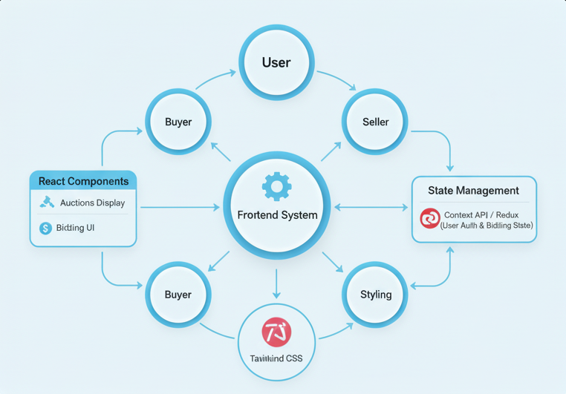
BACKEND SYSTEM
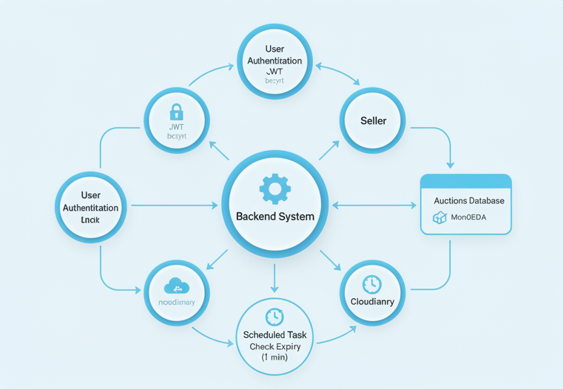

USER FLOW
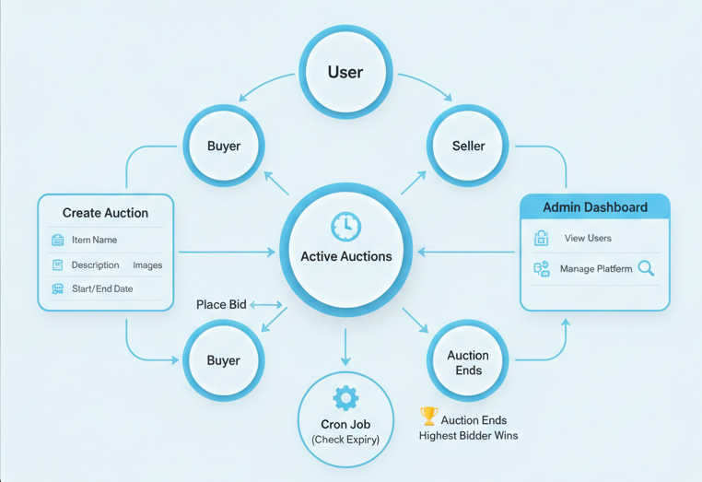
MODULES

1. User Module

- User registration and authentication (with cookies/JWT).

- User profile management.

- Option to act as buyer or seller.

2. Seller Module

- Create and list new auction items.

- Upload images and descriptions.

- Set start and end dates for auctions.

3. Buyer Module

- Browse available auctions.

- Place and update bids in real time.

- View auction history and results.

4. Admin Module

- Manage user accounts.

- Monitor and remove inappropriate listings.

- View overall system statistics.

5. Auction Management

- Automatic auction start and end.

- Highest bidder selection and notification.

- Real-time updates on ongoing auctions.

TECHNOLOGIES USED

1. Frontend
- React 19 (Vite + JSX)
- Tailwind CSS
- React Router v7+
- Axios
- TanStack Query (React Query)
- Redux Toolkit (for global state)

2. Backend
- Node.js + Express.js
- Multer (image upload)
- Cloudinary (image hosting)

3. Database
- MongoDB

4. State Management
- Redux

5. Authentication
- JWT & Cookies

6. Other Tools
- Mongoose, Cloudinary (for image upload), Postman (API testing)

PROJECT SCREENSHOTS

HOME PAGE


ABOUT PAGE
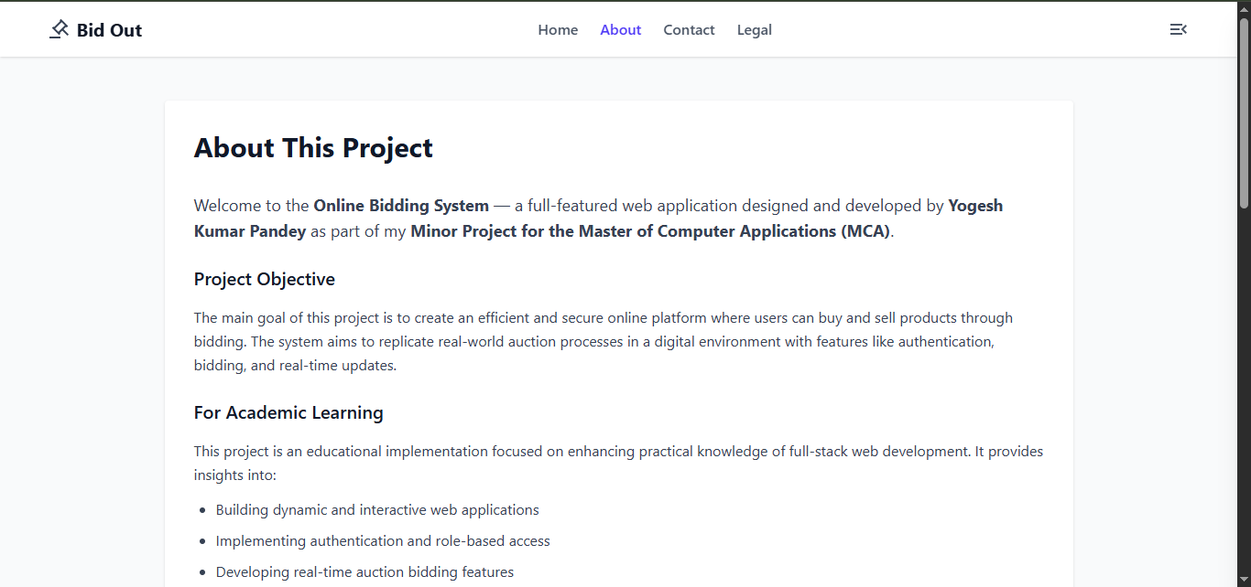

CONTACT PAGE
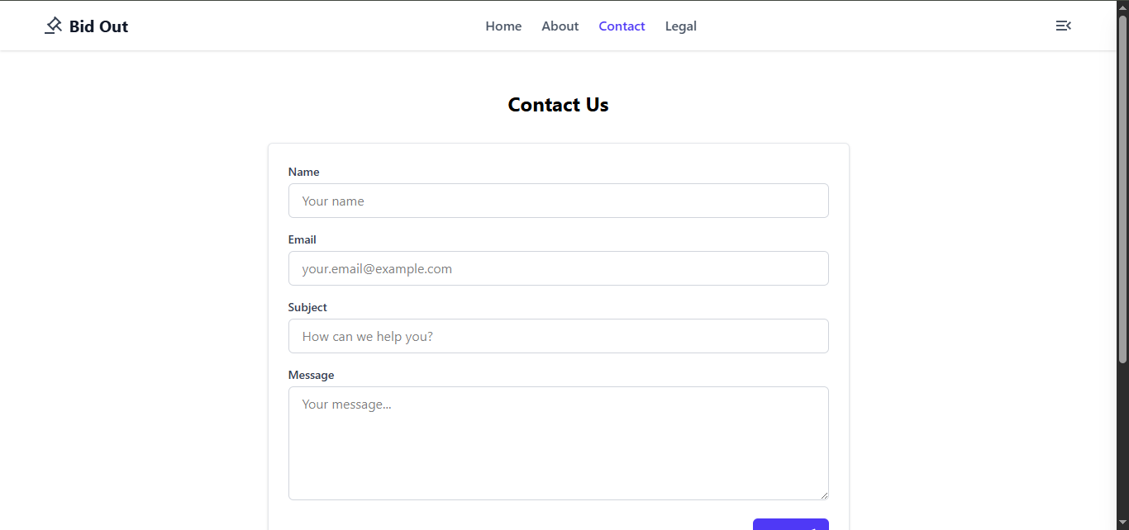

SIGN UP PAGE
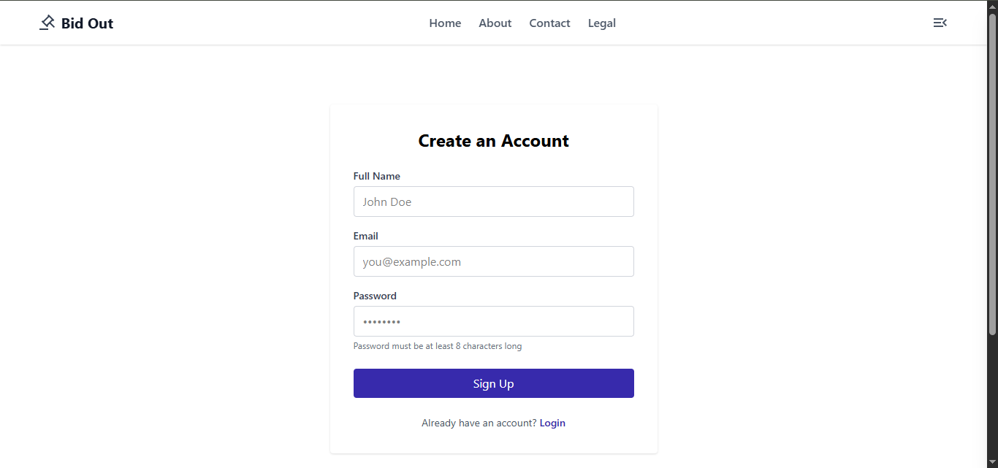

LOGIN PAGE
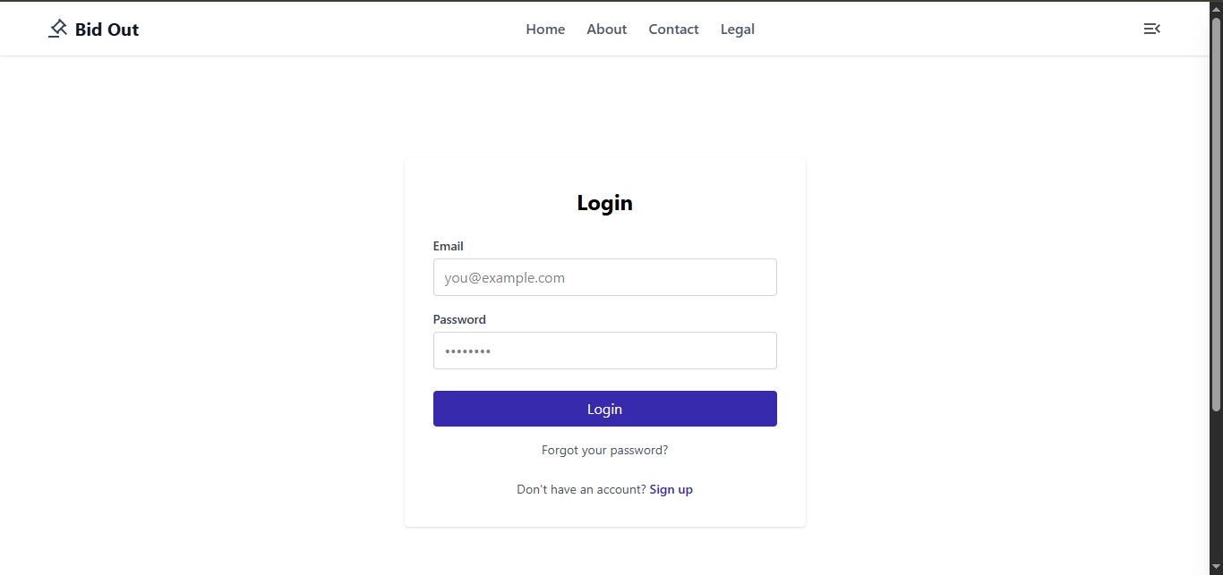

FUTURE ENHANCEMENTS

- Real-time Bidding - WebSocket integration for live auction updates

- Push Notifications - Real-time notifications for bid updates

- Payment Integration - Secure payment processing for winning bids

- Advanced Search - Filter and search auctions by category, price, etc.

- Auction Categories - Organize auctions by categories

- User Ratings - Rating system for buyers and sellers

- Email Notifications - Automated email alerts for auction activities

- Advanced Admin Tools - User management, auction moderation

CONCLUSION

The Online Auction and Bidding System successfully demonstrates how modern web technologies can be used to create a secure, efficient, and interactive platform for online auctions. It provides users with the ability to buy and sell products through real-time bidding in a transparent and convenient manner.

By integrating both frontend and backend technologies of the MERN stack, the system ensures smooth performance, responsive design, and secure data handling. It fulfills the objectives of providing a complete end-to-end solution for online auctions and showcases practical implementation of full-stack web development concepts.

This project serves as a foundation for future enhancements such as payment integration, mobile app support, and advanced analytics. Overall, it reflects the effective application of theoretical knowledge into a real-world, functioning software solution.

REFERENCES

- React.js Official Documentation – https://react.dev

- Node.js Official Documentation – https://nodejs.org

- Express.js Official Docs – https://expressjs.com

- MongoDB Documentation – https://www.mongodb.com/docs

- Cloudinary Image Upload Docs – https://cloudinary.com/documentation

- Tailwind CSS Documentation – https://tailwindcss.com/docs

- JWT Authentication Guide – https://jwt.io/introduction

- Node-Cron Scheduler – https://www.npmjs.com/package/node-cron

